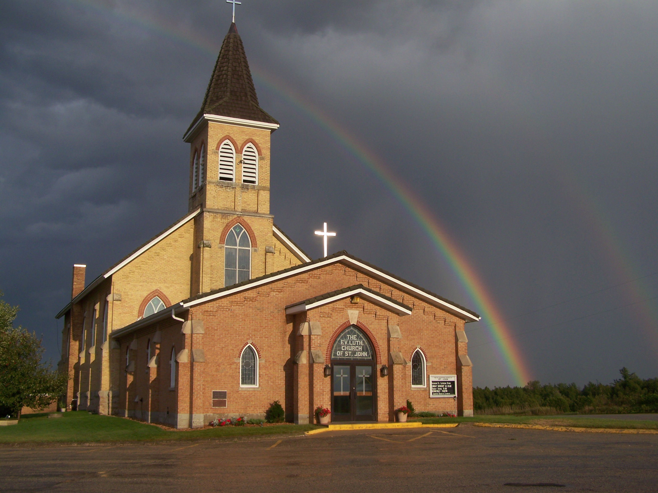
The Evangelical Lutheran Church of St. John
N1916 Church Road
Peshtigo, Wisconsin 54157-9673
Pastor Sargent 920-228-1061

07/23/2020
Dear members of St. John,
If there was a Fear Index, what do you think the current level would be? As of today, the 23rd of July 2020 I think the level would be through the roof. Will this COVID-19 pandemic ever end? There is so much news, on the TV, Radio, internet. Much of it is scary! It seems to be only bad news. Opinions are polarized. Mask or no mask? School districts, open or not? People are out of work. Businesses are struggling. There is trouble in our big cities with crime. You might be tempted to throw your hands in the air and say, “Will it ever get better again?”
Paul, in our text for Sunday’s message was addressing that very thought. His readers were dealing with a lot of fear. There was the mounting pressure from a public who were backed by the government. The Roman government declared the religion was illegal. It did not result in just a fine or a small jail sentence, they were tortured and killed in horrific ways.
Sound familiar? Is your fear level overflowing? Are you asking the question; “Will it ever get better?”
Paul’s message to the Roman Christians, and to us today is, of course, that, yes, it is all worth it. It will get better! In fact, it’s more than worth it. Join us for a message from God on Sunday the 26th of July. It is the 8th Sunday after Pentecost. We will be looking at Romans 8: 18-25. Theme: Will it get better?
Worship
We will worship with no more than 100 people in attendance for each service. At this time, we will not need to sign up before services because we have not gone beyond the occupancy limit.
If that happens, we will go to the sign up again.
- There will be two services on Sunday at 8:30 and 10:00.
- We will worship with no more than 100 people in attendance for each service.
- We will have portions of the church pews partitioned off to accommodate social distancing. Please be sure to sit only in the apportioned sections. Ushers will guide you to your seat of choice.
- No hymnals will be used. All service materials will be printed in the church bulletin, handed out to each member by an usher wearing a mask and gloves.
- We will not be passing offering plates in the worship service but will have them at the doors of the sanctuary where you may drop your offering.
- When church is over you will be ushered out. Please don’t get up and leave on your own. That will make it difficult to keep proper social distancing.
- We are not requiring that everyone wear a facemask, but please remember social distancing. If you feel comfortable wearing one, we encourage you to do so. Ushers will be wearing them.
Social Interaction

In order to maintain responsible social distancing, we are strongly encouraging the following:
- No physical contact: handshakes, hugs, fist bumps, etc.
- No gathering within church for socializing either before or after services.
- At this time all other church events, Bible Study, Sunday School, Ladies Aid and Quilting (etc.) will be on hold.

- If you are not feeling well or have concerns about your own health, you do not need to attend. We will continue with the Livestreaming service at 8:30. If you would like to receive private communion at home please contact Pastor Sargent.


Reminder of Important Information:



The Quarterly Voters Meeting will be held after the 10:00 am service on Sunday July 26. There will be an open forum before the meeting. All members are invited to attend the meeting.



Door Offering for Wesley Aguilar

Our new teacher Wesley Aguilar has been installed and is settling down in his apartment and getting to work at school. There will be an opportunity for members to welcome him by assisting him with the things he may need for his apartment and pantry. We are recommending gift cards or a gift of money to help him get settled. A door offering will be taken for Wesley on the 2nd of August, 2020.

Pastor Daniel Sargent

